Rationale for Unit Plan:

This unit is centered around travel and discovering new places, new cultures, and new people. The inspiration for the project comes from a children’s book entitled, “How to Make an Apple Pie and See the World” by Marjorie Priceman. For the purpose of the unit, we adapted the story in order to introduce students to Botswana through literature. The book tells the story of a young girl who wants to make an apple pie, but finds that the market is closed. She decides to travel the world to get the ingredients she needs to make the pie. We adapted the story in order to take students on a trip around Botswana. The adapted story is titled, “How to Make a Traditional Meal and See Botswana.” The activities are literacy based as students “travel” to four cities, picking up ingredients, and learning facts about each location.

The unit includes several universally designed adaptations and extensions that represent differentiated instruction to meet the needs of learners with intellectual disabilities in a third grade general education classroom. The e-book has an audio feature for all students. This feature allows students with visual impairments and low reading abilities to access the text. This book includes photographs taken as our group traveled to each city. The visual imagery will appeal to all students and provides cues to the text content. The content of the book is designed to be simple and concise so comprehension by all learners is more easily attainable.

During our classroom-based observations, we noted the engagement between teachers and students. The students are attentive and appear ready to learn. From our interactions with teachers, we discovered that schools do face challenges such as: limited resources and large pupil to teacher ratio. Based on these observations, we wanted to provide an activity that is engaging and includes visuals and hands-on activities adapted for a variety of learners. The book is available in both electronic and print form.

We hope this provides a model for teachers in both countries to adapt books for a variety of learners’ needs to support mastery of the educational standards. This lesson targets several content areas including science, social studies, math, language, etc. We hope teachers will use communication boards and other multisensory teaching tools through cooperative group learning to differentiate instruction to meet the needs of a variety of learners.
Lesson Components

- Pre-assessment
- Ask the students what do you know about Africa?
- Ask the students what their city, state, and country is in America
- Ask the students what they enjoy eating and what they think people in Botswana eat

- Introduction
- Learning about Botswana with the adapted book
- Understanding the similarities and differences between the two cultures

- Preview of Vocabulary
- Using different formats to introduce children to new vocabulary – written, visual, kinesthetic
- Semantic category maps in English and Setswana with word banks

- Read the adapted story (the teacher would have previously read the original story so that students are familiar with the events of the story)

- Activities with adaptions
- Map activity
- Sequencing
- Use text to complete semantic category charts
- Fill in the blank exercise

Activities:

Sequencing
- Where did we go first, second, third, fourth and what did we collect
- Adaptation – use pictures from the flashcards

Vocabulary Activity:

Semantic Category Charts

Word Bank:
- Mabele
- Morogo
- Seswaa
- Letswai
- Lephutshe
Word Bank:
- Greens
- Seswaa
- Salt
- Sorghum
- Pumpkin

Word Bank:
- Tonki
- Tlou
- Tau
- Kwena
- Thutlwa
- Kubu
- Kgomo
Word Bank:
- Donkey
- Elephant
- Lion
- Crocodile
- Giraffe
- Hippo
- Cow
Word Bank:
- Mokoro
- Sefofane
- Bese
- Jipi
- Sekotsekara
Word Bank:
- Canoe
- Plane
- Bus
- Jeep
- Donkey Cart

Word Bank:
- Dumelang
- O tsogile jang?
- Sala sentle
- Ke itumetse

Word Bank:
- Hello
- How are you?
- Goodbye
- Thank you

Map Activity

Objective: Child will place stars in the correct places that were discussed
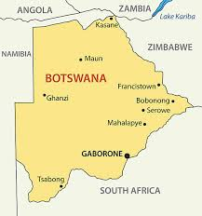

Fill in the Blank Activity

An animal with a long neck is ________________.

A mode of transportation in Botswana is _________.

An animal with a long trunk is _______________.

A mokoro is a _______________.

An important ingredient that you pound is __________.

A popular vegetable in Botswana is __________.

ANSWERS:
- Giraffe
- Canoe, bus, donkey cart, jeep
- Elephant
- Canoe
- Sorghum
- Morogo

Adaptation:

An animal with a long neck is ________________. (write/point)
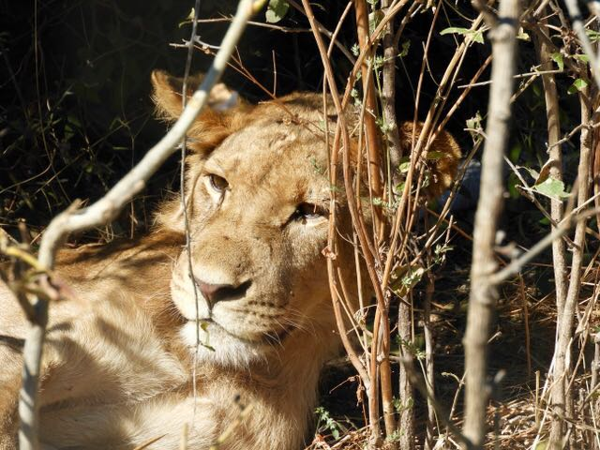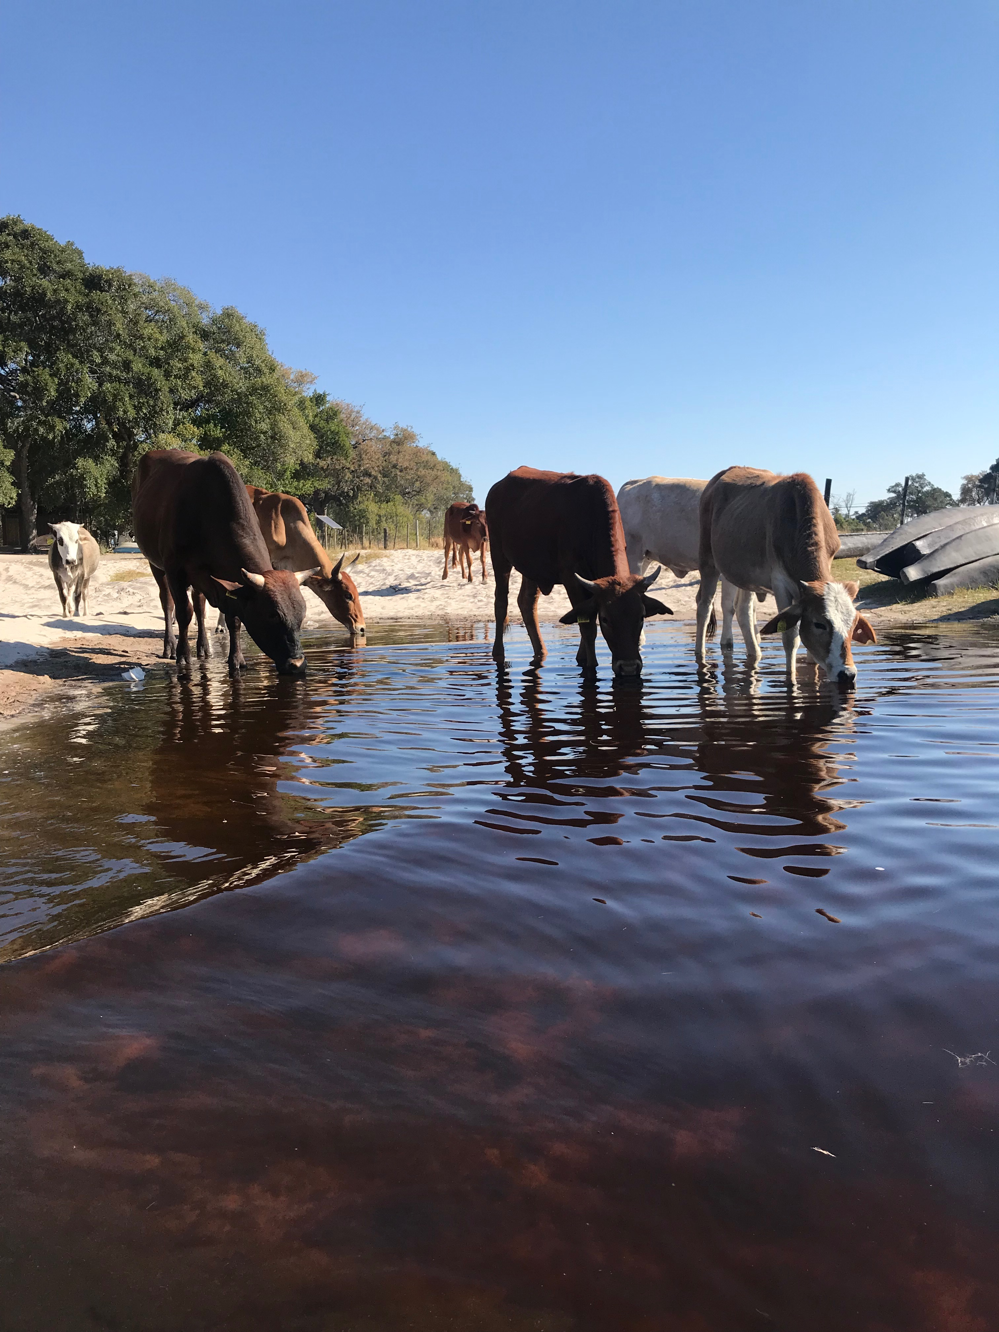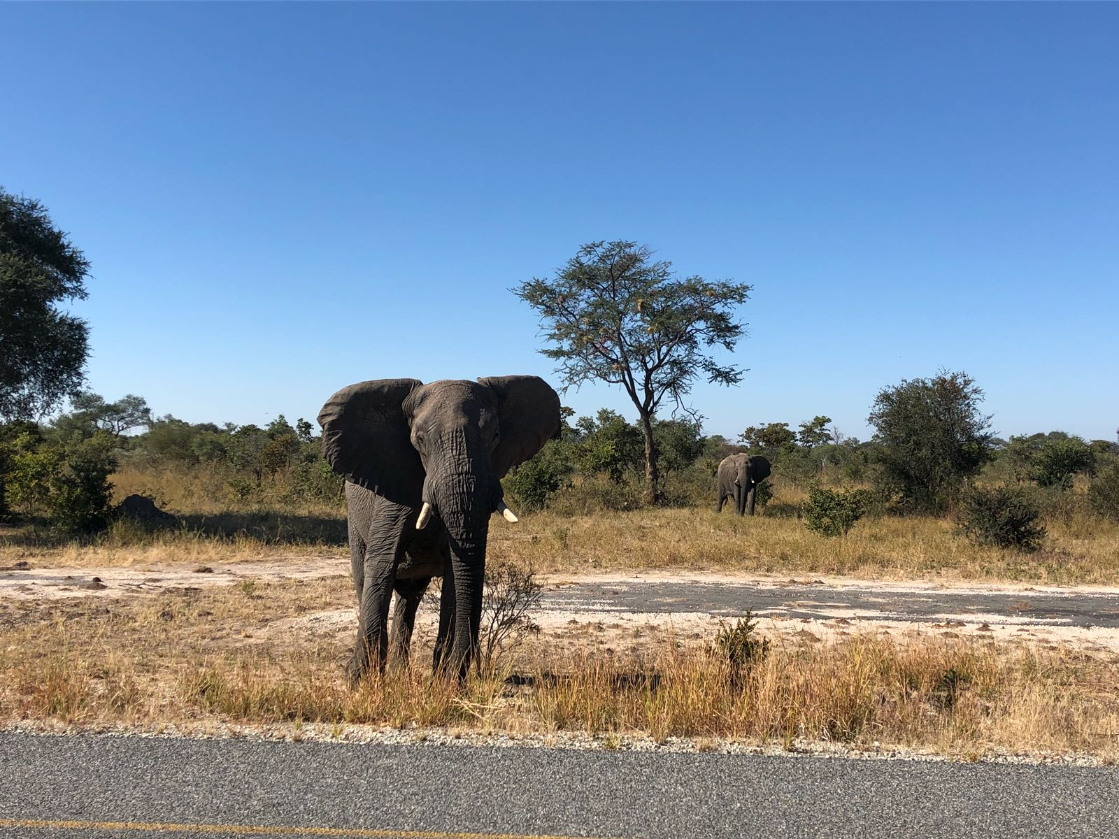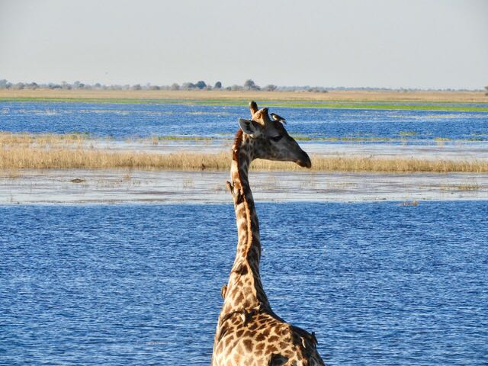

A mode of transportation in Botswana is ___________. (write/point)
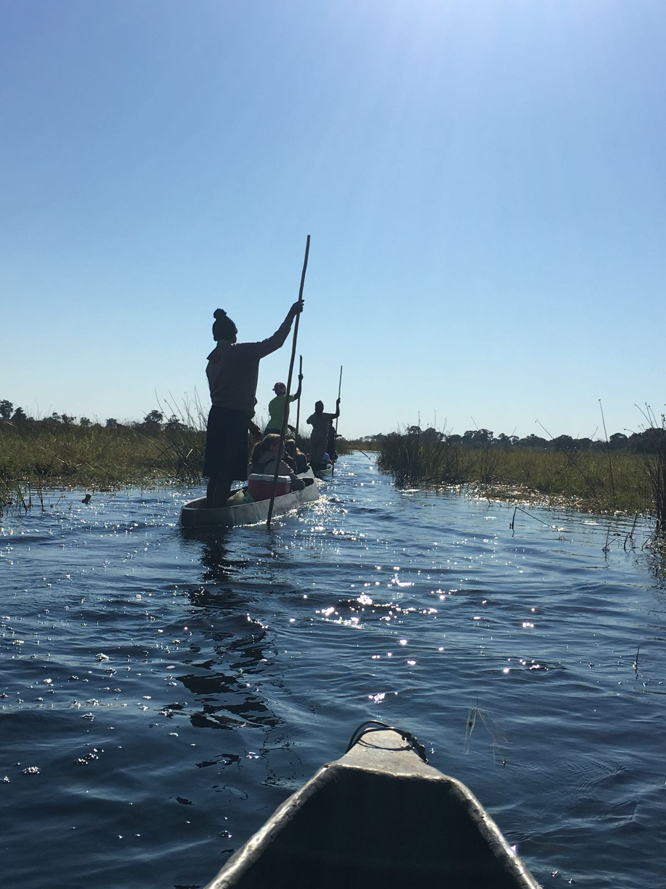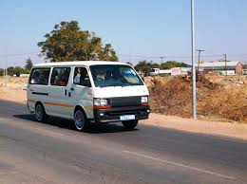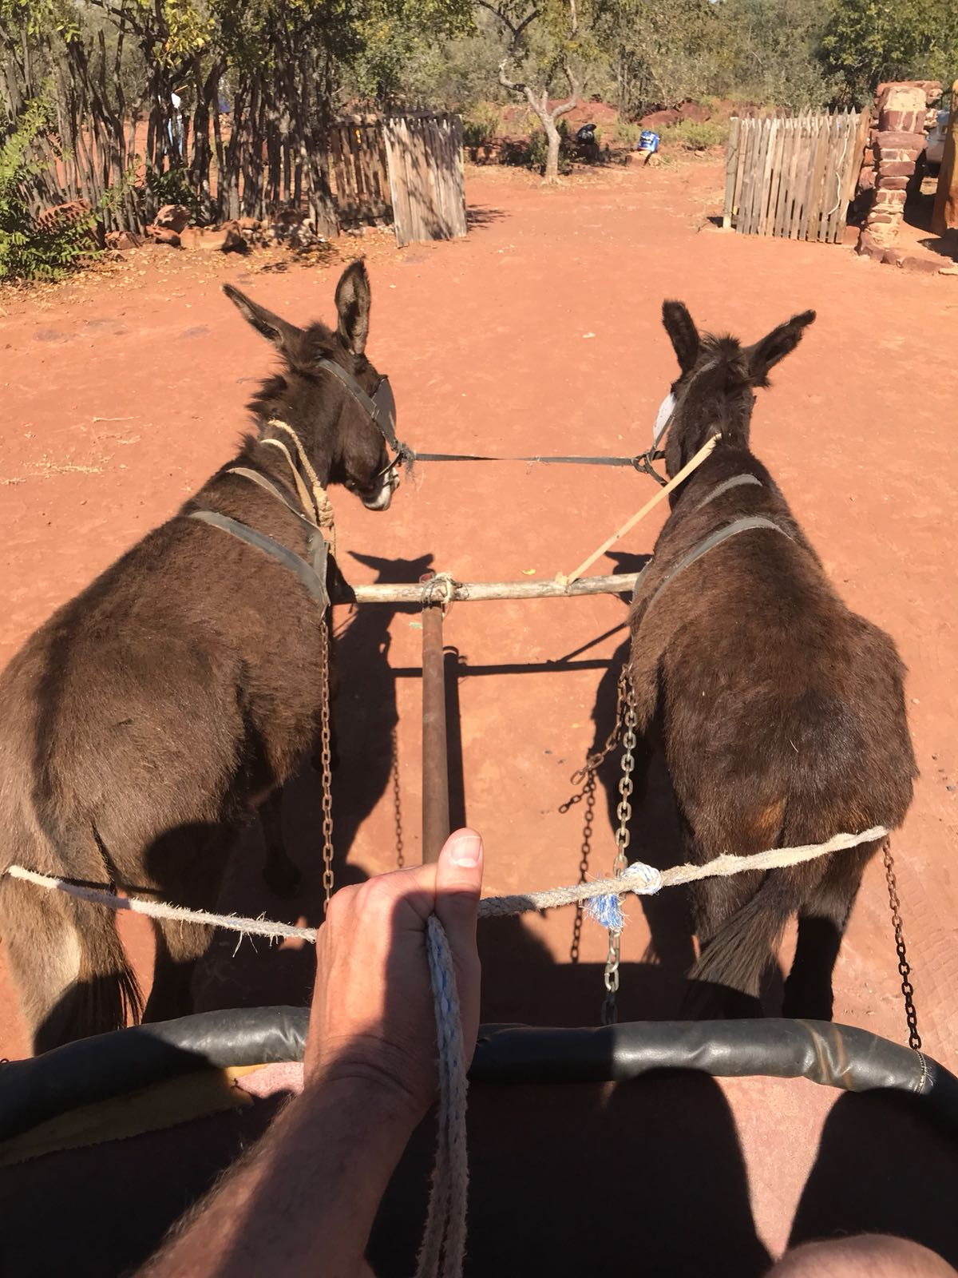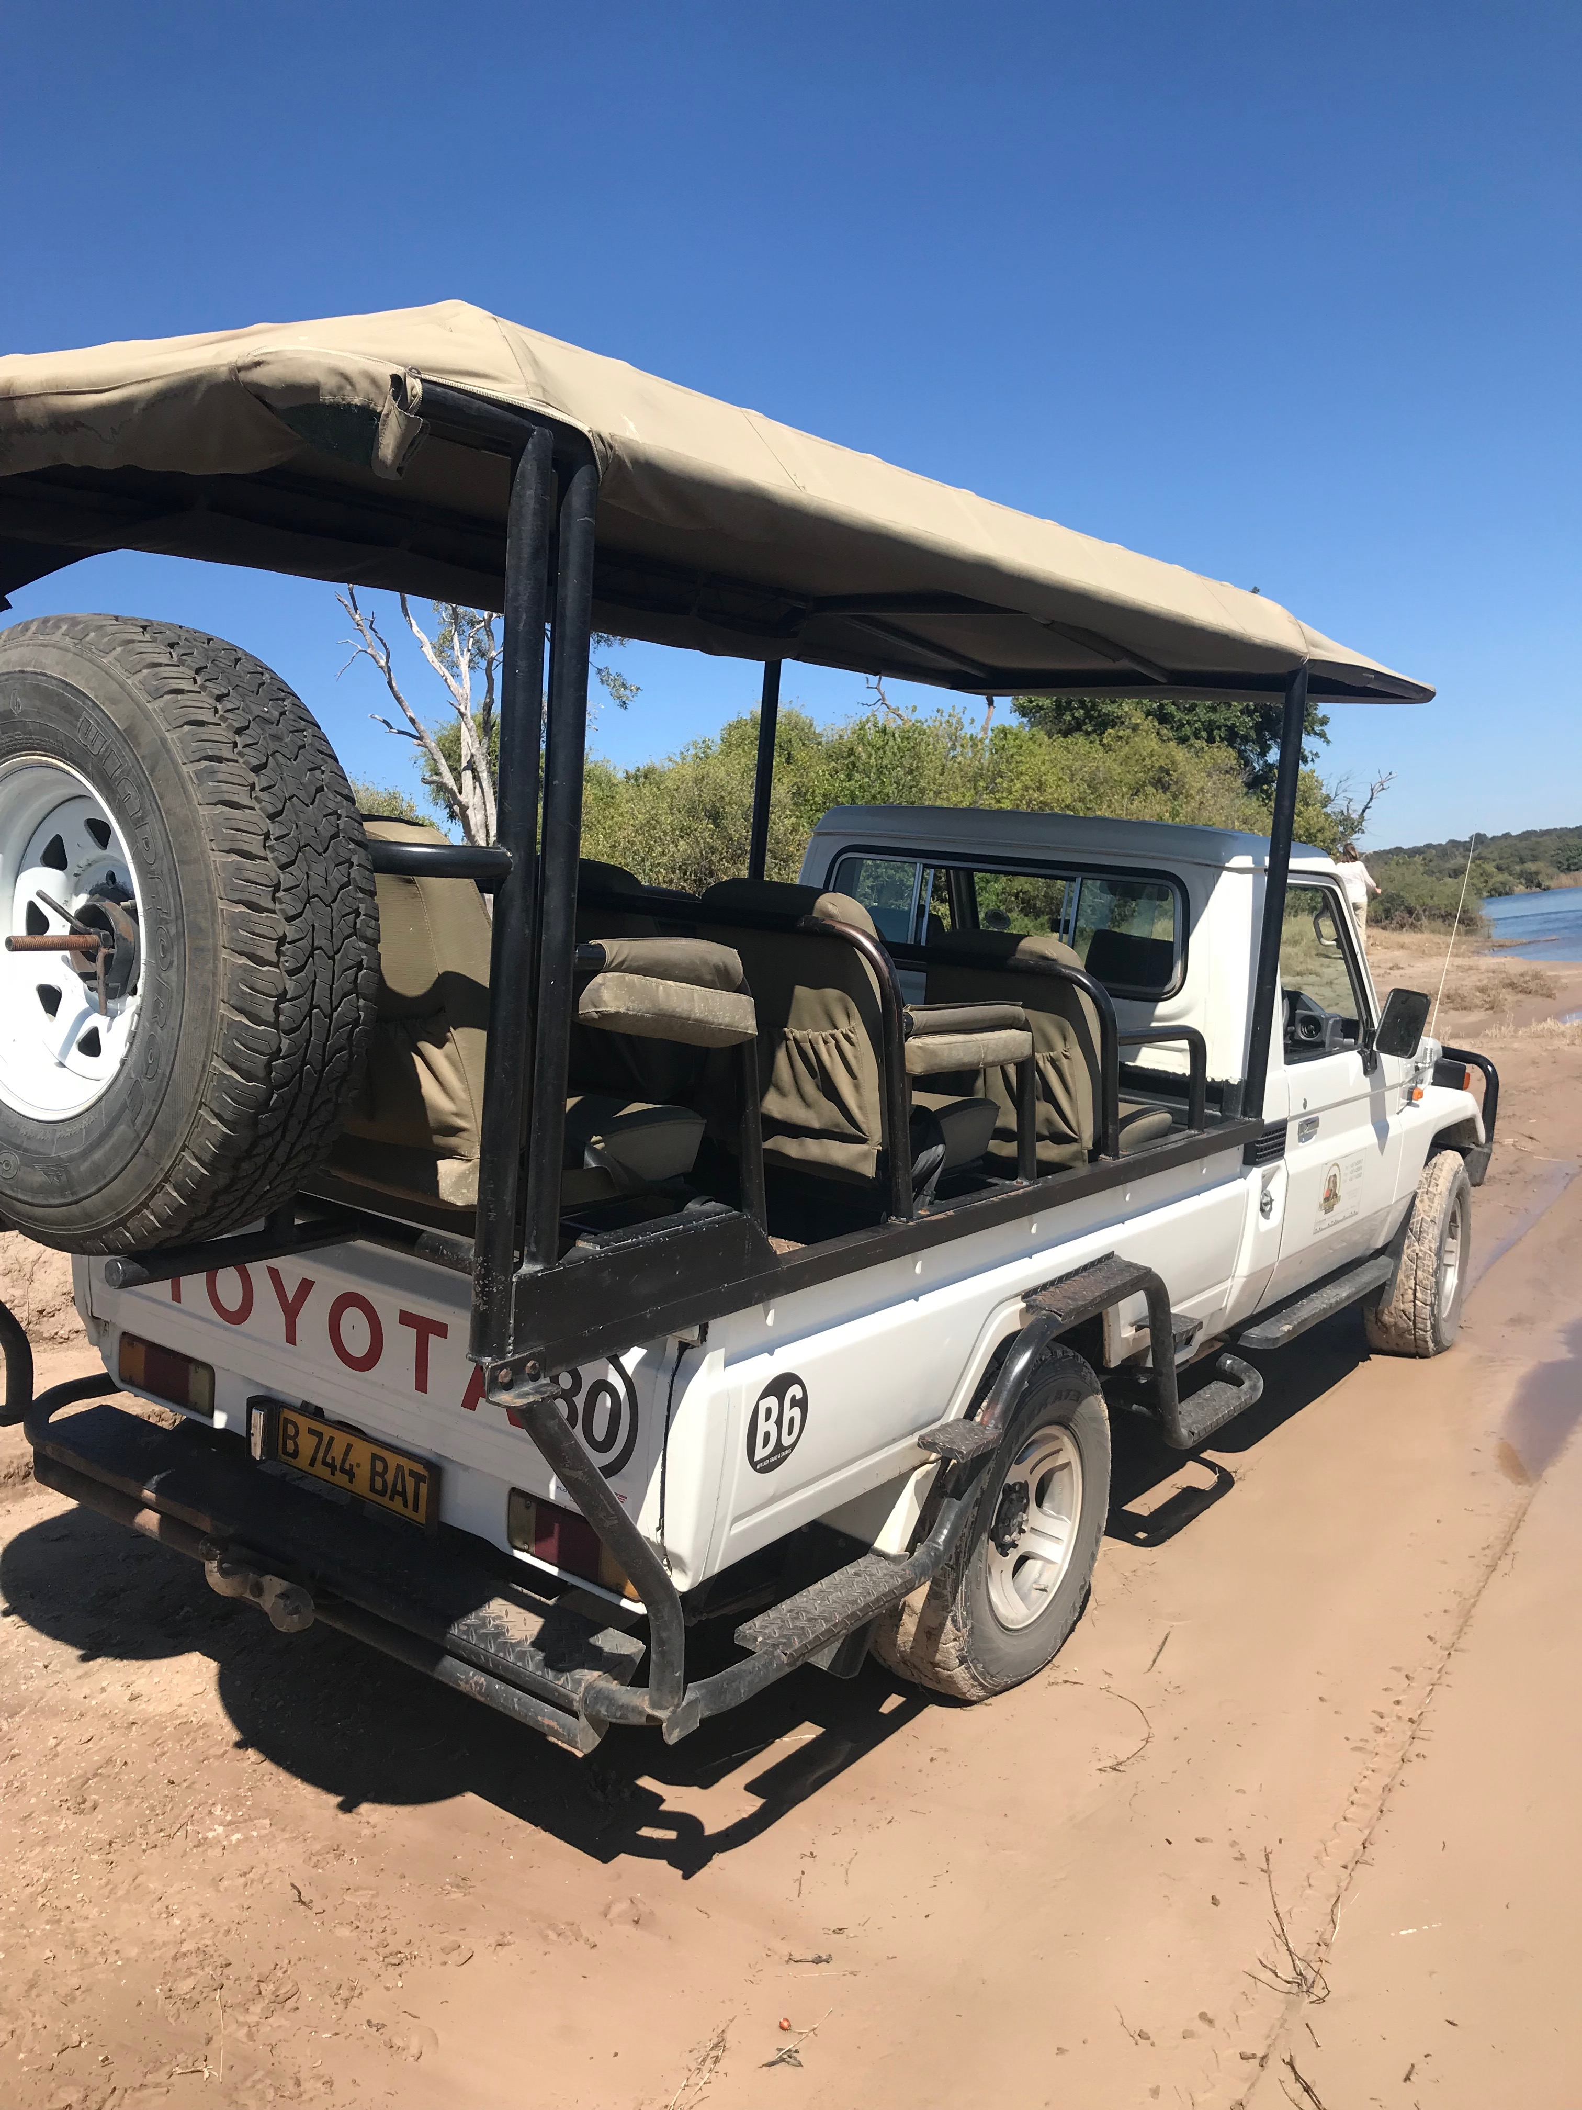

An animal with a long trunk is ___________. (point/write)
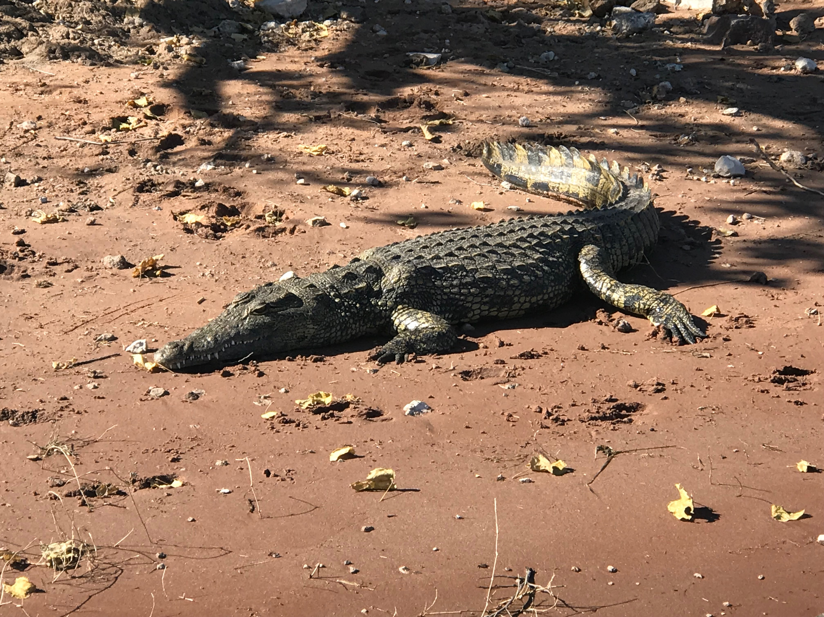

A mokoro is a _________. (point/write)

An important ingredient that you pound is __________. (point/write)
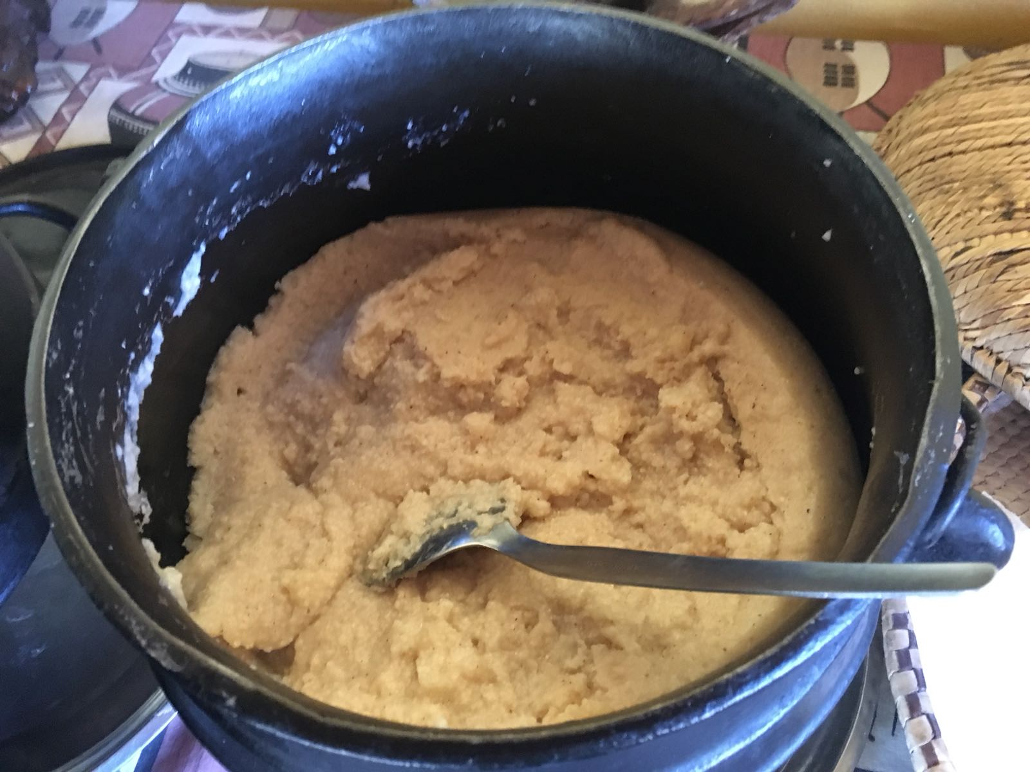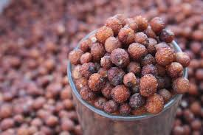

A popular vegetable in Botswana is __________. (point/write)
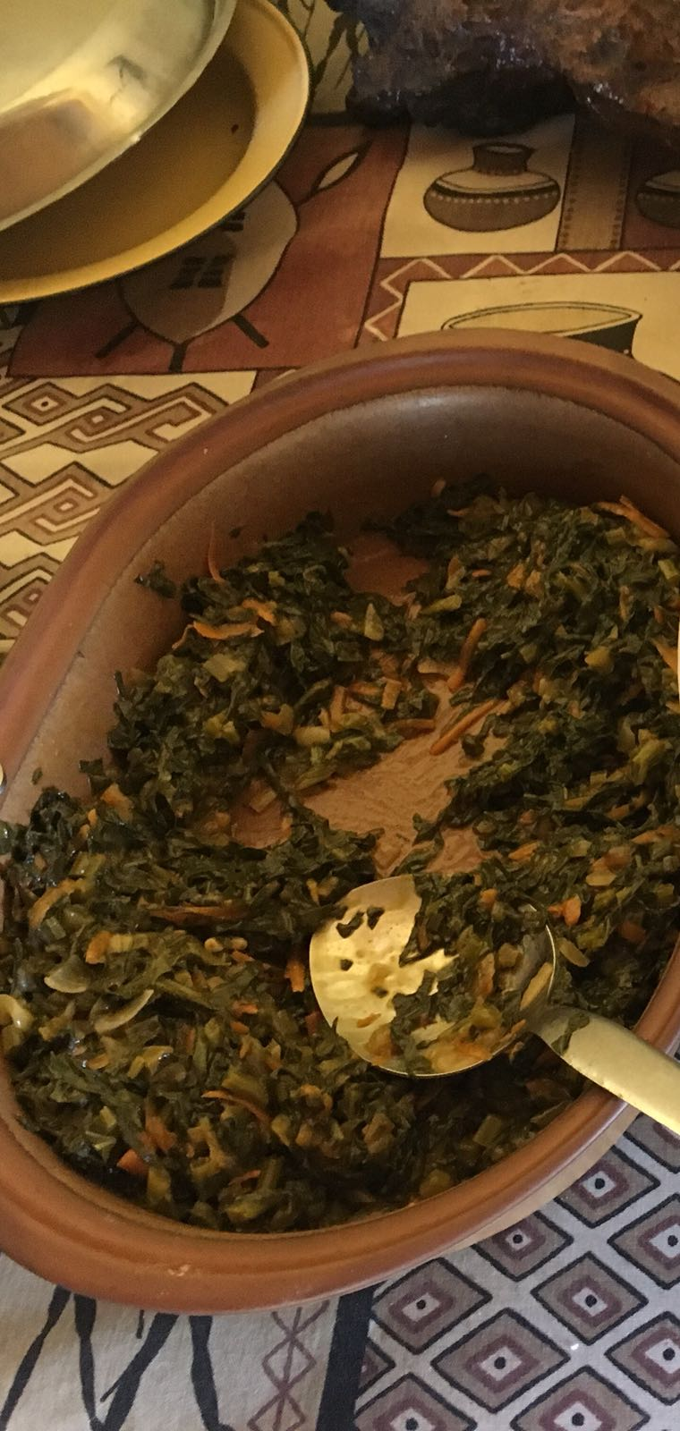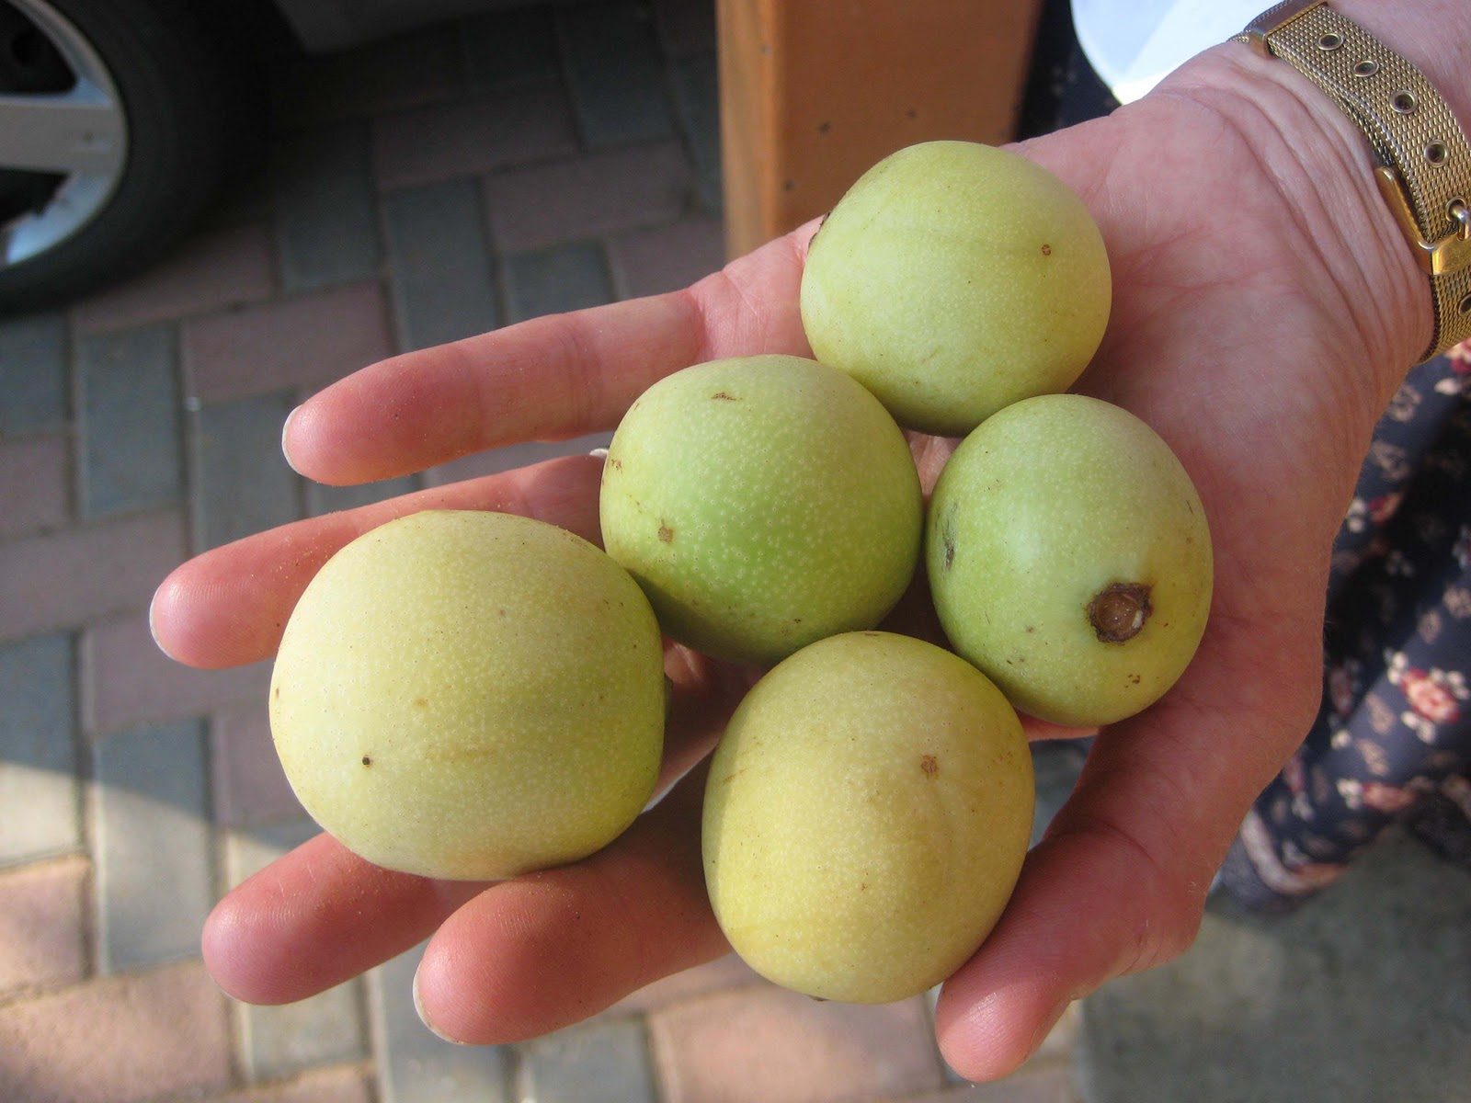

An animal with a long neck is ________________. (point)

A mode of transportation in Botswana is ___________. (point)

An animal with a long trunk is ___________. (point)

A mokoro is a _______________.

An important ingredient that you pound is __________. (point)

A popular vegetable in Botswana is __________. (point)

