Unit Plan: Nature Conservation in Botswana, Africa

Five Days: 45 minutes per day, 2-day Guided and Direct Instruction, 2-day Project Development, 1-day Project Presentation.

Unit Learning Objectives (from Heinemann’s Standard 5 English Pupil’s Text)
- Describe traditional methods of plant and animal conservation.
- Describe modern ways of conserving plants and animals in Botswana.
- Identify plant and animal species that are protected in Botswana.
- Discuss benefits of conservation to Botswana.
- Describe how communities can benefit from conservation and tourism.

North Carolina State Standards Correlation
CCSS.ELA- Literacy.rl.5.3
- Explain the relationships or interactions between two or more individuals, events, ideas, or concepts in a historical, scientific, or technical text based on specific information in the text.

CCSS- Science.5.L.2.3
- Infer the effects that may result from the interconnected relationship of plants and animals to their ecosystem

Materials/Resources Used in Unit
Books:
Apps, P., Branch, B., Cuthbert, E., MacLarty, S. & Schaum, J. (2009). My first book of Southern African wildlife. Struik Nature: Cape Town, South Africa.
- Great reference for students with mild ID or SLD students due to the pictorial of animal and its ecosystem

Greaves, N., & Clement, R. (2000). When hippo was hairy: And other tales from Africa. Struik Nature: Cape Town, South Africa.
- Great reference for students with hearing impairment or language disorder. It would also be a great extension activity for AIG students as an additional reading assignment.

Phirie, D., Tsimanyane, O., Withey, T., & Monteith, M. (Editor). (Date). Heinemann English for standard 5; Pupil’s book. Heinemann: UK.
- Botswana standard 5 lesson, chapter 3 that was referenced and modified for this lesson plan

Scheffler, A. (2014). Flip flap safari. Nosy Crow Ltd.: London, England.
- Great reference for students with language disorder (sequencing) or ID

Additional Supports for Universal Design for Learning (UDL):
Note: UDL encourages multiple modes of learning: engagement, expression, and presentation. If this content is inappropriately demanding of any student, adapted curriculum may be used such as simplified, hands-on storybook, matching terms, discussion of related books with Augmentative and Assistive Communication, etc. Expression of learning may take any appropriate alternative form as determined by the teacher.

Visual support: Image 1 (African animal in natural habitat), Image 2 (Map of 10 Botswana Game Reserves)

Animal slides/Flashcards

Sign Language Vocabulary Video

Communication Board

“Things we Need to Live” checklist

Modified Text Handout modified with highlighted keywords and simplified/minimized text

Hands on Modified Book

Leveled Bubble Map Template

Matching Terms Handout

Modified Project Handout

Sign Language

ASL Interpreter

Project Rubric

Student Self Assessment

Preplanning
- Write the lesson agenda on the board as a visual support/visual schedule. This is especially helpful for students with ASD
- Collect and print materials from Nature Conservation Lesson using the google drive link
Potential Barriers for Learning:
- Engagement/ Attention/ Focus
- Translation of vocabulary into ASL for Hearing Impairment
- Mild/Moderate Language Impairment
- Other specific learning disability
Day One:Lesson One

Opening/Hook

- Display Image 1
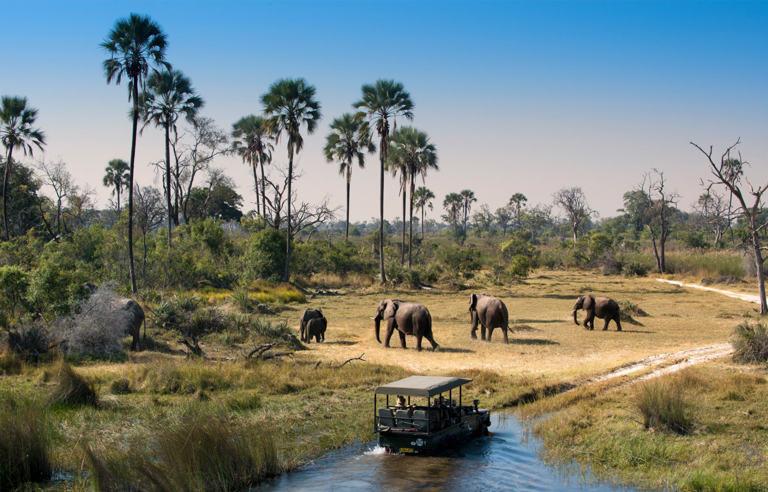
Teacher: “Raise your hand if you have ever heard of nature conservation. This is the Big Idea for our Science Class this week.”

Assessment of prior knowledge:

Teacher: “If nature conservation is related to this image, what do you see?”
- Semantic Mapping via “Bubble Map”for brainstorming, connecting ideas, vocabulary development.
- Students are to copy bubble map from the board by drawing their own or using a leveled template
- See Nature Conservation Semantic Mapping doc

Pre-teaching and Expanding on Big Idea:

Teacher: “How do you think the Big Idea of Nature Conservation is connected to animals, the environment, people and jobs?”
- Write in central bubble: Nature Conservation. Add four spurs: environment, animals, people, jobs
- Ask students to copy the bubble map as it develops to keep for notes to use for projects. As students develop further ideas, build on with additional spurs
- See Nature Conservation Semantic Mapping doc

Guided Instruction:

Teacher: “Let’s make a list on the board of some of the things we must have in order to live.”
- Create a numbered list.
- Ask students to copy as they are listed. Offer modified list as needed.
- Display visuals of some of these items that students brainstorm.
- See Things We Need to Live doc

Teacher: “Let’s put a check mark by the ones that come from nature. We call these “natural resources.”

Teacher: “Did you know that every day we are using resources such as fertile soil, water, plants and animals?”

Teacher: “Did you know that we must have fertile soil, water, plants, and animals in order to live? Learning about the importance of protecting these things in nature is very important. This is what nature conservation is all about; protecting our natural resources like so that we can continue to live healthy lives in a healthy environment.”
- Point out items on bubble map and list
- See Nature Conservation Semantic Mapping doc

Teacher: “So now let’s read and talk about traditional ways of nature conservation in Botswana, Africa. Please follow along in your handout as we share reading aloud by sections. We will stop for your responses to each section on totems, hunting seasons, big predators and beliefs or taboos.”
- Pass out informational text
- Use modified text for learners with intellectual disability, ASD, or another specific learning disability
- See Nature Conservation Modified Text doc

Teacher: “Who would like to get us started?”

Teacher: “In the US we have many modern ways of protecting animals. We practice recycling, have laws that protect endangered species, and set aside large areas of land in our national park system. Has anyone ever visited a national park or game reserve? Please raise your hand and tell us where you went.”
- Write names of parks on the board

Teacher: “In Botswana, there are ten areas of land set aside by the government for protection or conservation.”
- Display Image 2
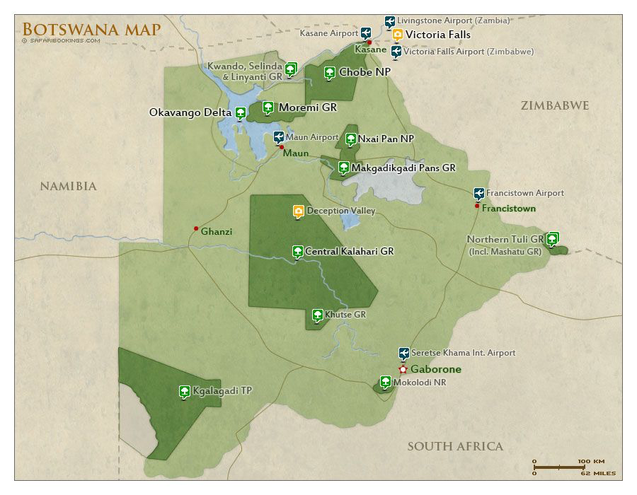

Teacher: “It is so important to protect certain animals in Botswana that they are protected by strict rules or conservation laws that are enforced by park officials. Although some more common animals may be hunted under certain conditions (like kudu and impala), it is illegal to kill a protected animal in Botswana. Education programs in schools teach all citizens in Botswana about the importance of nature conservation. Also, there are some special breeding programs that allow certain farmers to raise rare animals in order to increase the number of them so that they will not become endangered or go extinct. Raise your hand if you know what extinct means? Who knows what endangered means?”

Teacher: “So let’s see if we can list some animals that are protected by the Botswana government. This means that they may not be hunted or killed at any time. The official language in Botswana is English, but the Setswana language is very important to the people of Botswana, so we will learn the Setswana name sign name for some of the most important animals on our list.”
- Display Animal Slides.
- Make a list on the board as slides are displayed and ask students to copy.
- Use modified list of animals as needed.
- List may include: brown hyena, cheetah, giraffe, hippopotamus, rhinoceros, wild dog, Chobe Bushbuck, leopard, elephant, kori bustard, eagles, vultures, storks, herons, secretary bird, sable antelope, lion, eland.
- Include the Setswana name and sign for the most important of the animals.
- Display sign language video. Incorporate sign language as a form of kinesthetic learning. Pause the video and have the students repeat the signs, the English name, and the Setswana name
- See Protected Animals Flashcards ppt
- See Sign Language Video
- See Vocabulary Matching HO doc

Teacher: “Tomorrow we will talk about the benefits of nature conservation. Benefits are good results that come from doing something. Be thinking of some reasons why you think African animals should be protected!”

Teacher: “Also, I want you to start thinking about a project that you’d like to work on that shows either traditional ways of conservation like the ones we read aloud, or modern methods of conservation like parks and reserves, laws, public education and breeding programs. Or you can do one on recycling, protected animals, or on the topics we will discuss tomorrow like protected plants, or benefits of conservation. Projects can be your choice...maybe a mini-book, a collage with pictures and words, a painting, a poster, a song, a story, a comic strip, Google slide presentation, or shoebox project. Here is a list of topics and ideas. Choose something you are very interested in and a project format that sounds like fun for you!”
Day Two: Lesson Two

Hook

- Watch the youtube video, “How the Zebra Got Its Stripes.”
- In a small group, reinforce the story with the hands on modified version of the story for learners with intellectual disability, ASD, or another specific learning disability

Review of Previous Lesson:

Teacher: “Please take out your bubble maps and lists from our lesson yesterday. What did we discuss? Please raise your hand to answer.”

Guided Instruction:

Teacher: “Now let’s take a look at some a protected plants in Botswana.”
- Display images of selected plants which may include timber trees such as pod mahogany, Rhodesian teak (mukusi), Tsaudi, Mukwa, or Brown mahogany. Fruit trees such as Baobab (Mowana), Mozinzila and African ebony (mokochang).

Teacher: “We also want to take some time to think about the benefits (or good results) of nature conservation. Let’s make our notes on a bubble map of how those benefits of nature conservation help people, help out the country of Botswana with money and jobs from tourism, and how they help the environment.”
- See Nature Conservation Semantic Map doc

Teacher: “For our “people” bubble, Is it fun for people to see wild animals in their natural environment? Is it a good idea to protect the African cultural heritage for future generations? Is it helpful to learn about plants and animals in a natural setting rather than in unnatural places like zoos? Do you think it’s a good idea to have a wide variety of plants and animals in our environment?”
- Draw in key words onto bubbles as indicated
- See Nature Conservation Semantic Map doc

Teacher: “For the country of Botswana, is it good for people from all over the world to come as tourists? Do they spend money? What do they spend money on: hotels, restaurants, game parks, adventure activities, buy crafts made by local artists? What kinds of jobs are provided by this tourism?”
- See Nature Conservation Semantic Map doc

Teacher: “What helpful things can the people of Botswana spend their money on? (Food, clothes, housing, electricity, cars, technology…)
- Draw in key words onto bubbles as indicated
- See Nature Conservation Semantic Map doc

Teacher: “How can the environment benefit from nature conservation? (Healthy plants and animals, clean air, clean water, less erosion from healthy plants)
- Draw in key words onto bubbles as indicated
- See Nature Conservation Semantic Map doc

Lesson Review:

Using completed bubble map, review concepts from lesson 1 and fill in any needed blanks together.

Project Introduction:

Teacher: “This is a good time to decide on your project and write down the steps you need to take to get it done. You will also need to make a list of supplies you will need. Our next two classes will be spent working on your project with my assistance and feedback. You may also choose to work with a partner. If you do, you will need to also write down what each of you will do and how you will work together. Are there any questions? I will be giving you a rubric so that you will know what you will need to do to have a great project and an awesome grade on it. On Friday, I will draw names and you can share your project with the class. We will be learning from each other, so let’s be both good students and good teachers!”
- Pass out rubrics and the project handouts to the students
- See Rubric below
- See Project Handout doc
Days Three and Four: Lesson 3 and 4

- Independent and partner work in class with consultation and feedback
- Move around the room and check in with each pair of partners about their progress
- See Rubric below
- See Project Handout doc
Day Five: Lesson 5
- Project sharing
- See Rubric below
- See Project Handout doc
Assessment
Ongoing assessment
- Put check marks for each student concerning: class participation, adequate note-taking in bubble maps, copying lists, and project planning.

Final assessment
- Use the rubric to grade the projects (planning, time management, content included in the project and quality of final project) and student self assessment
- See Rubric below
- See Student Self Assessment below

Rubric

 | 5 points | 3 points | 1 point
Planning | Project Plan is turned in on time. | Project plan is turned in, but not on time. | Project plan was not turned in.
Time management | Productive, focused time spent on-task and in class on Days 3 and 4. | Some re-directing needed, but on-task and productive. | Un-focused and unproductive despite re-direction.
Lesson content | Project topic is clear and includes at least 5 facts from the lessons. | Topic is clear and includes at least 3 facts from the lessons. | Topic and/or lesson content isnot clear. Only 1 or 2 facts from the lesson.
Quality (teacher) | Very high quality | Good quality, but could do better if stayed on-task. | Low quality. Did not put the time in to have a quality project.
Quality (student) | Very high quality | Good quality, but could do better if stayed on-task. | Low quality. Did not put the time in to have a quality project.

Student Self Assessment

How do you think your project turned out?
Would you do anything differently?
What grade would you give yourself on this project?

