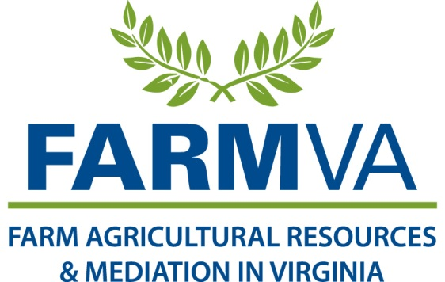

**Agreement to Mediate with**

**Acknowledgement of Access to Information and Confidentiality Agreement**

This is an Agreement to Mediate between _________________ and ____________________.

Mediation is a voluntary method of resolving disputes. In mediation, the parties meet to discuss the issues facing them and communicate with the assistance of a third party mediator. All parties recognize that mediation is a voluntary settlement negotiation and that the mediator is not a judge and has no authority to force a settlement on the parties.

*Mediators are neutral.* The mediators will not advise the parties.

*Consultation With Attorneys*. The parties recognize that the mediator is not giving legal counsel or analyzing anyone’s legal rights. The parties may seek legal representation if they believe it is in their best interest.

*Persons With Disabilities*: Any person with disabilities who requires alternative means for communication of program information (Braille, large print, audio tape, etc.) should contact USDA’s TARGET center at 202-720-2600 (voice and TDD).

*Private Sessions (Caucuses).* The mediator may hold brief sessions with only one party. These private sessions are intended to improve the mediator’s understanding of the party’s position. Information gained in a private session is confidential unless the party agrees to have it brought up in joint session.

*Confidentiality:* The parties recognize that the mediation is confidential and that the settlement negotiations and any actions taken in this mediation process are inadmissible in any litigation of their dispute, to the maximum extent allowed by law. The parties specifically agree they will not subpoena, depose, or otherwise attempt to require the mediator or FARMVA staff or volunteers to testify or produce records, notes, or work product in any future proceedings.

There are exceptions to the confidentiality rule. The following must be reported: 1) child or elder abuse, 2) plans for future crimes involving serious bodily harm or death, 3) crimes committed during the mediation.

__________**X**

**Initial here to Acknowledge Understanding of Agreement to Mediate __________X**

*Disclosure*. It is understood that complete and honest disclosure of all relevant information is essential to successful mediation. Although the parties are not required to volunteer information or to answer any questions, the parties agree that all disclosures will be truthful and that the parties will not deliberately mislead each other by disclosing only partial information, or in other ways.

*Agreement*. When an agreement is reached, the mediators will record the terms of that agreement on behalf of the parties. The parties may sign the agreement at the mediation session, or may review the agreement with their attorney before the document is placed in final form and signed. No agreement will be binding on any party, as to any subject, unless in writing, signed by those to be bound by the agreement, expressing their intent that agreement is binding.

*Failure to Reach Agreement.*  The parties recognize that the mediator’s role is to facilitate communication between the parties. Neither FARMVA nor the mediator is responsible for the failure of the parties to reach agreement. No person will hold the mediator liable for the results of the mediation, whether or not a resolution is reached. The parties understand that if they do not reach agreement in a case referred to the FARMVA, they may have the option of filing an appeal with the National Appeals Division.

*USDA Position on Mediation:* The USDA’s policy is to encourage mediation and they have agreed to attend the meeting and participate in good faith. However, ___________ cannot agree to any settlement that is impermissible under the law. ____________ representative who attends your mediation will know which program requirements can legally be waived. The representative will attempt to discover through mediation new facts and information that may have been relevant to the adverse decision. When this occurs, the representative may agree in mediation to present or forward the new information to the appropriate authority to reconsider the determination or consider granting relief. However, the parties to the mediation understand that the official receiving the representative’s recommendation is not bound to either reconsider the determination or accept the recommendation.

*NCAMP’s Retention of Records.* The parties understand that the only mediation records that NCAMP or the mediator will retain are the Agreement to Mediate with Acknowledgement of Confidentiality and Acknowledgement of USDA Access to Records, the letter appointing the mediator, the Request for Mediation, the final agreement (or non-agreement) signed by the parties, and the intake form that includes contact information. These records will remain on file for at least 5 years with the Mediation Service Provider.

*Auditing*. The parties understand that for the purpose of auditing, the USDA, including the USDA Inspector General, the Controller General of the United States, the NRCS Chief (if an NRCS mediation), the Administrator, and any of their representatives will have access to pertinent records described above as necessary to monitor and to conduct audits, investigations, or evaluations of mediation services funded in whole or in part by the USDA.

***NRCS Mediations Only****-Privacy*: Privacy of any information relating to personal information of the Natural Resources Conservation programs will be in accordance with Section 1244 of Title II of the Farm Security and Rural Investment Act of 2002 (Public Law 107-171, 116 Stat. 235).

**Initial here to acknowledge USDA Access to Records __________X ­­­­­­­­­___________X**

*Complaints*: If the parties to the mediation have any complaints of discrimination, they may file a written request with the USDA Director, Office of Civil Rights, Room 326-W, Whitten Building, 1400 Independence Avenue, Stop 9410, Washington, DC 20250-9410, or by telephone to 202-720-5964 (voice and TDD). If the parties to the mediation have any complaint about the mediator, they may contact NCAMP’s Executive Director, Brian Clarke at 908.272.8153.

**Initial here to acknowledge complaint procedure_______X ___________X**

We, the undersigned, agree to mediate according to the above terms and guidelines.

Date:       Date:

____________________________**X**

____________________________**X** _____________________________ **X**

Party to Mediation Part(ies) to Mediation

**Acknowledgement of Confidentiality**

I, the undersigned, agree that I will maintain the confidentiality of North Carolina Agricultural Mediation Program (NCAMP) mediations. I agree not to disclose, rely on, nor introduce as evidence, in any mediation, arbitration, judicial, or other proceeding, the information that is disclosed during the mediation; nor will I divulge such information to any person for any purpose. Such information includes, but is not limited to:

1. views expressed or suggestions made by another party with respect to a possible settlement of a dispute;
2. specific content of mediations and documents produced during mediation;

3. admissions or statements made by any person in the course of the mediation proceedings;

4. proposals made or expressed in the mediation;

5. statements or conduct which might be interpreted as any party’s willingness or unwillingness to accept a proposal for settlement made during the mediation; and

6. terms of the final agreement.

_______________________________X _________________

Signature of Participant Date

_______________________________X _________________

Signature of Participant Date

**All Participants please sign and date**